Lab 13b - Tor and the Darkweb

To download the tor browser meant going to Tors website <https://www.torproject.org/download/>

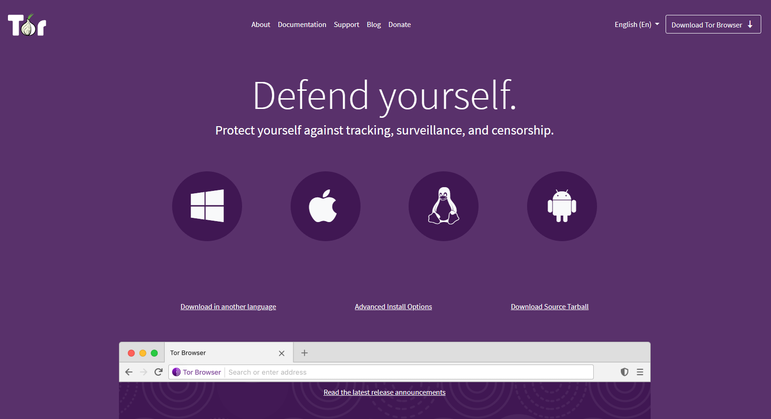

Downloading and installing the Tor bowser onto my desktop

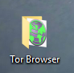

Logging into the to browser gave me a configuration menu

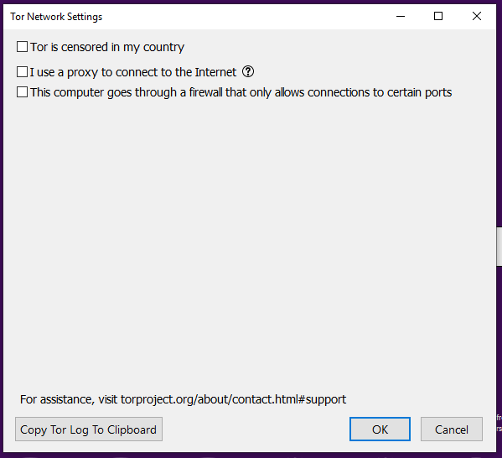

Once finished, I set the security settings to the Safest

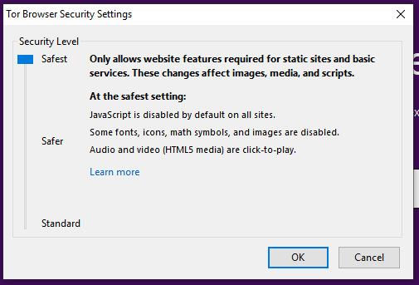

With these settings configured we naviagate to [www.itb.ie](http://www.itb.ie) and can track our circuit over 3 hops to non .onion sites

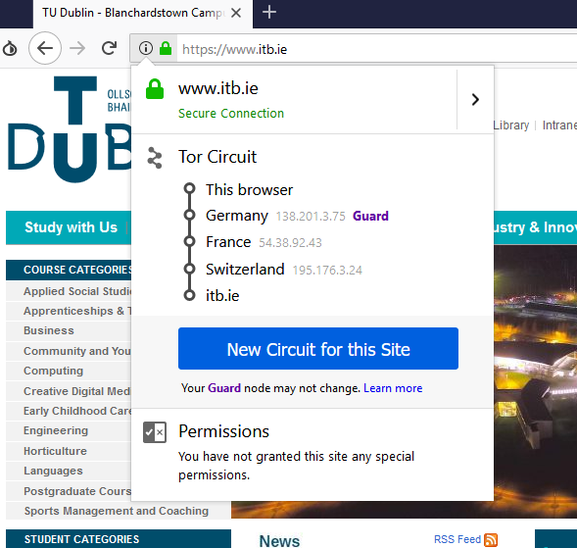

Check this on an onion site for example facebook <https://facebookcorewwwi.onion/> you can clearly see there is the normal hops followed by multiple relays expanding the possible hops from network to network as 6

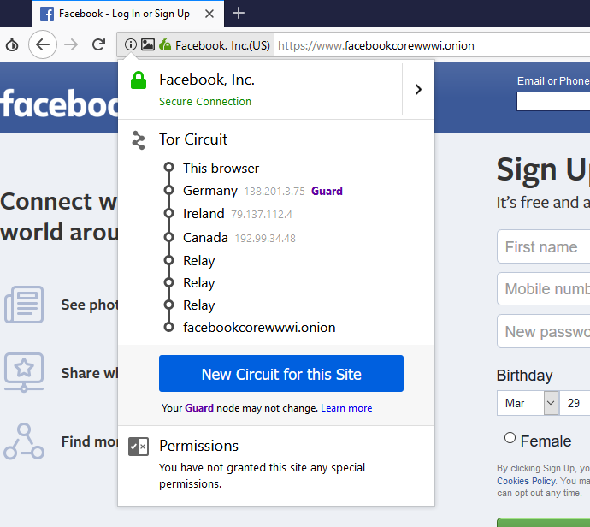

Getting restricted content we go to [www.cbs.com](http://www.cbs.com) and on a normal browser not configured with a VPN we see this region restriction 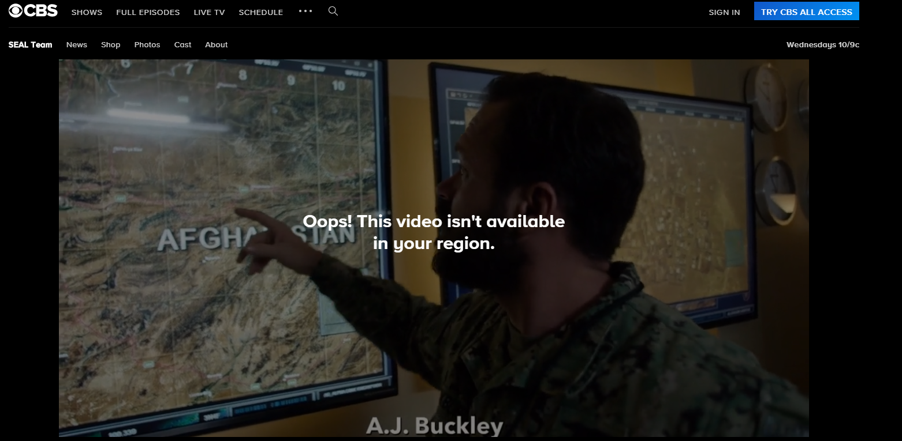

Trough the tor configured browser what we first see is this because there is scripts running on the website that have been blocked by the browser security settings.

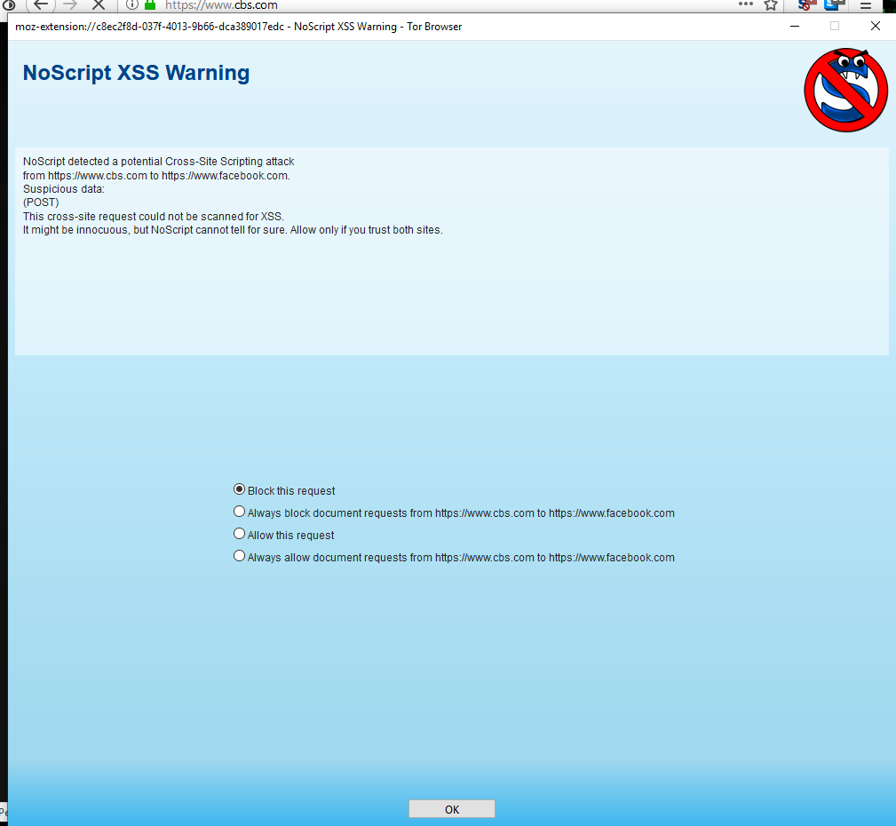

Allowing these scripts on the website but still have region based issues, so what we need to do is chose a different circuit to get to a country that allows viewing of the content such as the us

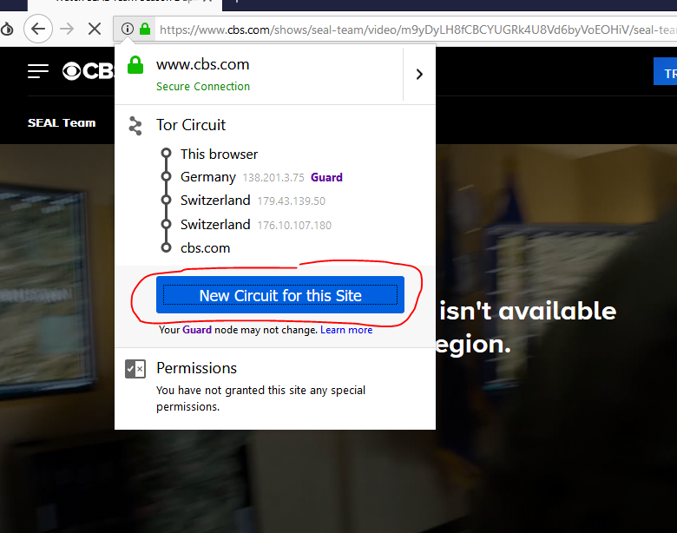

we can now see the content with no region based issues.

